**Assignment-3**

|  |  |
| --- | --- |
| **Team id** | PNT2022TMID49581 |
| **PROJECT NAME** | CUSTOMER CARE REGISTRY |
| **NAME** | MAHARAJA V |
| **ROLL NO** | 950019104023 |

**1.Create a Bucket in IBM object storage.**

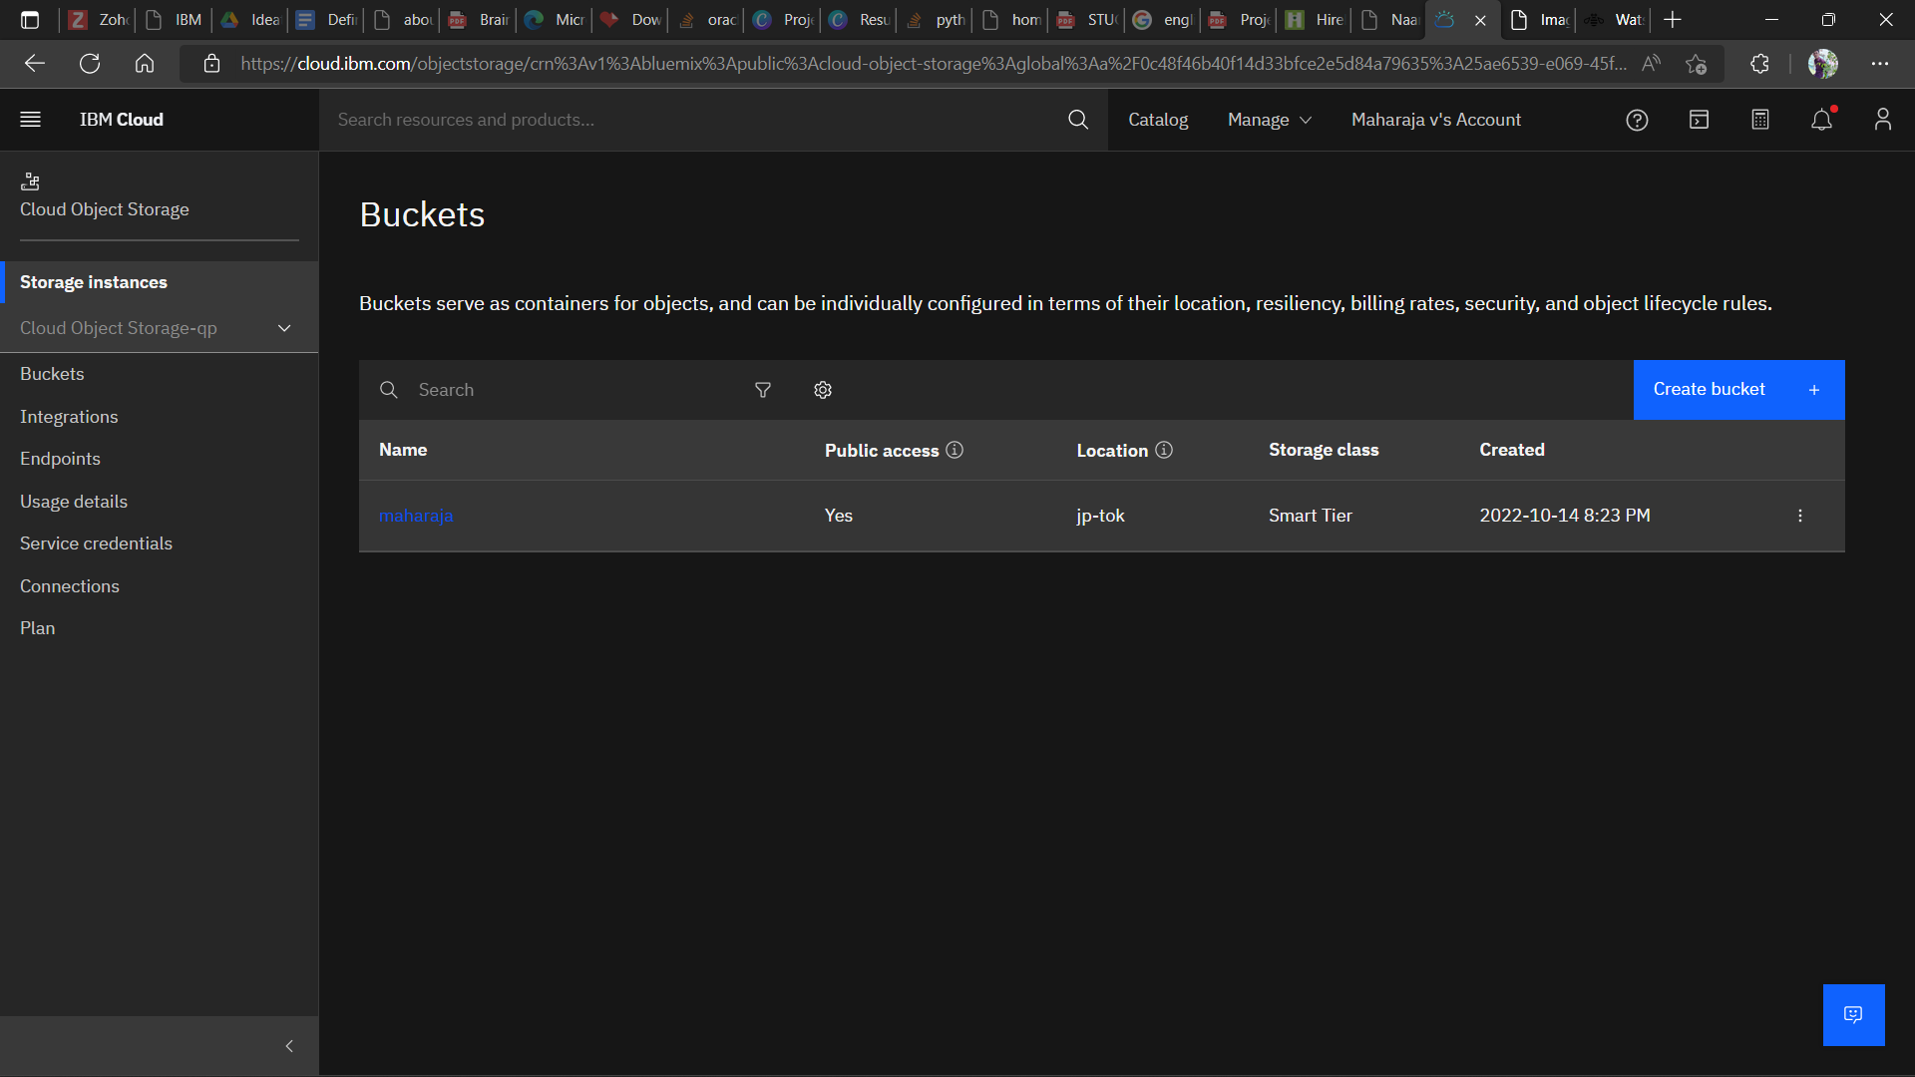

**2.Upload an 5 images to ibm object storage and make it public. write html code to displaying all the 5 images.**

web.html:

<html>

<head>

<title>

Images

</title>

<link rel="stylesheet" href="https://maharaja.s3.jp-tok.cloud-object-storage.appdomain.cloud/style.css">

</head>

<body>

<div class="box">

<div class="img1">

<h1 class="word">Car</h1>

<img src="https://maharaja.s3.jp-tok.cloud-object-storage.appdomain.cloud/car.jpg" alt="Car" width="200" height="200">

</div>

<div class="img2">

<h1 class="word">Computer</h1>

<img src="https://maharaja.s3.jp-tok.cloud-object-storage.appdomain.cloud/computer.jpg" alt="Computer" width="200" height="200">

</div>

<div class="img3">

<h1 class="word"> Forest</h1>

<img src="https://maharaja.s3.jp-tok.cloud-object-storage.appdomain.cloud/forest.jpg" alt="Forest" width="200" height="200">

</div>

<div class="img4">

<h1 class="word"> Moon</h1>

<img src="https://maharaja.s3.jp-tok.cloud-object-storage.appdomain.cloud/moon.jpg" alt="Moon" width="200" height="200">

</div>

<div class="img5">

<h1 class="word"> Parrot</h1>

<img src="https://maharaja.s3.jp-tok.cloud-object-storage.appdomain.cloud/parrot.jpg" alt="Parrot" width="200" height="200">

</div>

</div>

</body>

</html>

**Output:**

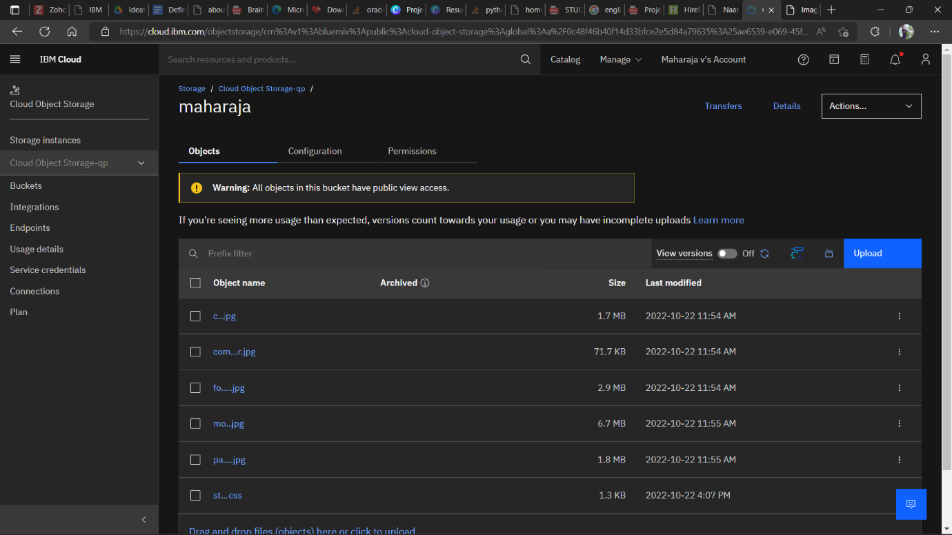

**3.Upload a css page to the object storage and use the same page in your HTML code.**

@import url('https://fonts.googleapis.com/css2?family=Alkalami&display=swap');

body{

top: 0;

left: 0;

width: 100vw;

height: 100vh;

margin: 0;

padding: 0;

font-size: 1vmin;

font-family: 'Alkalami', serif;

color: white;

background: linear-gradient(90deg, #00249cad 0%, #c409c7b6 100%);

}

.word{

text-align: center;

text-transform: uppercase;

color: rgb(231, 226, 225);

}

img{

border-radius: 3px;

position: relative;

top: 34%;

left: 50%;

transform: translate(-50%, -50%);

width: 99%;

height: 70%;

}

.box{

border-radius: 3px;

height: 600px;

width: 700px;

background: linear-gradient(90deg, #46fcfc 0%, #fb3f7acb 100%);

display: flex;

flex-wrap: wrap;

flex-direction: row;

position: relative;

top: 50%;

left: 50%;

transform: translate(-50%, -50%);

}

.img1 ,.img2 ,.img3, .img4, .img5{

border-radius: 10px;

height: 220px;

width: 150px;

margin: 15px;

border: 1px solid rgb(224, 23, 23);

background: linear-gradient(90deg, #76b74b 0%, #ad4343bd 100%);

}

.img1{

margin-left: 60px;

}

.img2{

margin-left: 50px;

}

.img3{

margin-left: 50px;

}

.img4{

margin-left: 170px;

}

.img5{

margin-left: 50px;

}

**Output:**



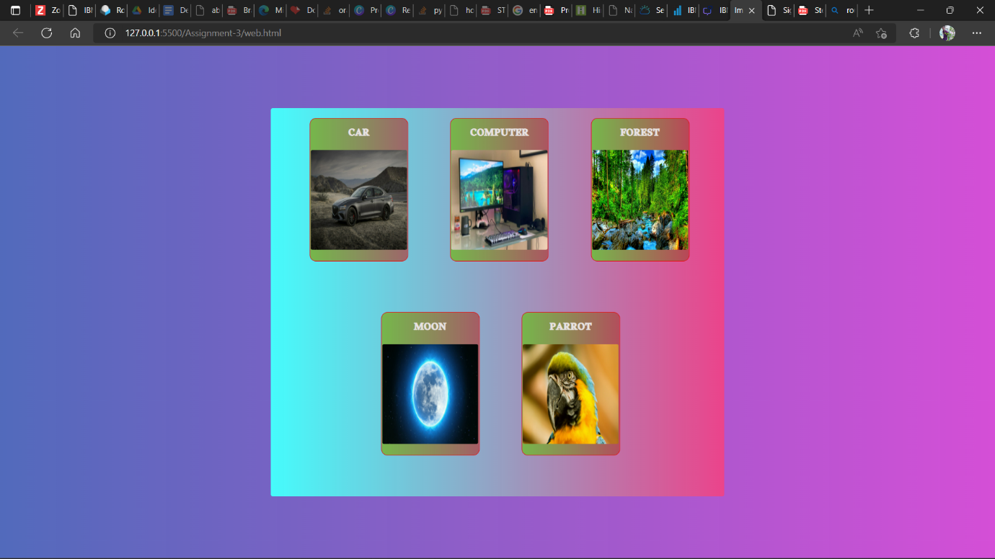

**4.Design a chatbot using IBM Watson assistant for hospital. Ex: User comes with query to know the branches for that hospital in your city. Submit the web URL of that chat bot as a assignment.**

<https://web-chat.global.assistant.watson.appdomain.cloud/preview.html?backgroundImageURL=https%3A%2F%2Fau-syd.assistant.watson.cloud.ibm.com%2Fpublic%2Fimages%2Fupx-5dc2386a-6b6c-41bb-a967-367c1fd36937%3A%3A2c6246a7-bc21-4a98-a920-46f013dcc982&integrationID=ef9de879-7b4e-4532-913e-44b2f1157c57&region=au-syd&serviceInstanceID=5dc2386a-6b6c-41bb-a967-367c1fd36937>

**5.Create Watson assistant service with 10 steps and use 3 conditions in it. Load that script in HTML page.**

**Index.html:**

<html>

<head>

<script>

window.watsonAssistantChatOptions = {

integrationID: "ef9de879-7b4e-4532-913e-44b2f1157c57", // The ID of this integration.

region: "au-syd", // The region your integration is hosted in.

serviceInstanceID: "5dc2386a-6b6c-41bb-a967-367c1fd36937", // The ID of your service instance.

onLoad: function(instance) { instance.render(); }

};

setTimeout(function(){

const t=document.createElement('script');

t.src="https://web-chat.global.assistant.watson.appdomain.cloud/versions/" + (window.watsonAssistantChatOptions.clientVersion || 'latest') + "/WatsonAssistantChatEntry.js";

document.head.appendChild(t);

});

</script>

<meta charset="UTF-8">

<title>Medical bot</title>

<link rel="stylesheet" href="style.css">

</head>

<body></br></br></br></br></br>

<img src="" alt="">

<div align="center">

<div align="center" class="border">

<div class="header">

<h1 class="word"></h1>

</div></br></br></br>

<h1 class="bottom">

Hi I am Raja</br></br> Welcome to Our page...

</h1></br></br></br>

</div>

</div>

</body>

</html>

**Output:**



